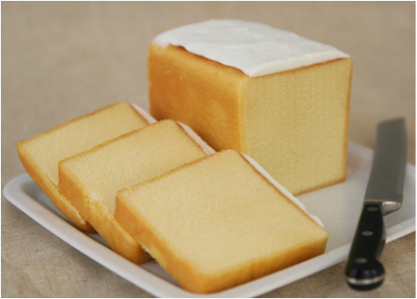

Holy Cross Home & School Association will be selling Stock’s Pound Cakes!! Pre-Order is a must.
Cost: Each cake “brick” is $15.00
Orders are due by: Friday March 15, 2019. -Send into school with a Holy Cross School Student. Checks can be made out to Holy Cross Home & School Association, please write your phone number on your check.
QUESTIONS: TEXT or Call: Jodi Campbell, Cell# 610-308-1097 -OR-
Kathleen Williams, Cell# 610-213-6549
**Pick up Date: Saturday March 30, 2019 from 2:30p.-4:30p. @ Holy Cross Gym/ Annex Kitchen area
**Please send Payment and BOTTOM of Order form below in an envelope marked “Home & School Pound Cake” ________________________________________________________________________
Holy Cross Home & School Association Stock’s Pound Cake Fundraiser 2019
Name: (Please Print)______________________________________________________________________
CELL Phone#__________________________ Student Name:__________________________
Holy Cross Parishioner? Yes:______ No:_______ Holy Cross School Family? Yes:_______ No:______
TYPE | QUANTITY | TOTAL
Vanilla PLAIN– NO Icing
Vanilla with Vanilla Icing
Vanilla with Chocolate Icing
Marble Cake with Vanilla Icing

Total Due:$________________________________

