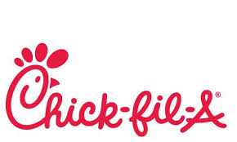
Holy Cross Home & School Special Hot Lunch for 5/23/2019
$6.00 per meal

Please fill out form below And Include the proper payment by Thursday May 16th.

choose FROM:
Chicken NUGGETS, a Bag of Chips & DRINK
or
Chick Fil A Original Chicken SANDWICH, A bag of Chips & DRINK
- **No Regular Hot Lunch is available on 5/23/19. If you choose not to order lunch for your child/children; please send in a packed lunch for them.
- please Use one order form for each student order.
- Please write special hot lunch and your students name and grade on outside of envelope.
Please Detach order form Below and send into school with your payment by 5/16/19

**H&S Special Hot Lunch for Thursday 5/23/2019 Order Slip:

Student’s full Name: (Please Print)____________________________________________________________
Grade: __________________

Please make your selection by marking an “X” on which meal you wish to order. ***Please use one form per student in your family!

_________1 Order of Chicken NUGGETS, 1 Bag of Chips & DRINK = $6.00

_________ 1 Original Chick-fil-a chicken SANDWICH, 1 Bag of Chips & DRINK=$6.00

Amount Enclosed: $_________________

