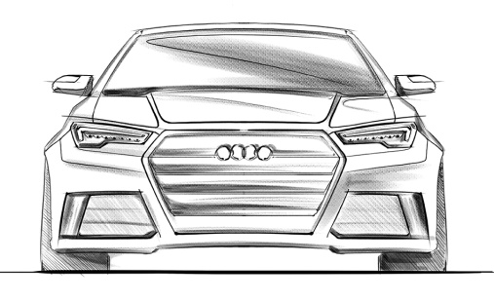

Please Print your family name big and bold in the middle of this sheet:

