The Holy Cross Student Council
Presents:
The Candy Count
2 Jars of candy =2 chances to win!
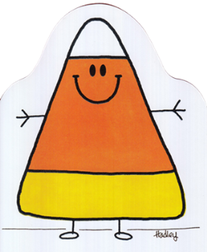
Try to guess how many pieces of candy are in each jar!
You could win the candy along with the
Hidden Surprise Inside!
Thursday, October 24th –Tuesday, October 29th
Purchase chances in the cafeteria during morning recess or your lunch period
Chances are $.25 for 1 or $1.00 for 5
**Winner will be announced during lunch on
Wednesday, October 30th**

