Annual Holy Cross Turkey Trot
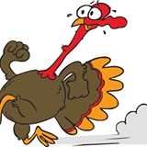
Tuesday, November 26th
Holy Cross school yard
Walk or Run – Prizes will be awarded!
*to participate Donate the food item
assigned to your class *
*You can wear your gym uniforms*

