January

2020
Sunday | Monday | Tuesday | Wednesday | Thursday | Friday | Saturday
 |  |  | 1 | 2 | 3 | 4
We will be collecting socks, hats and scarves  this month. |  |  | Happy New Year! | Classes Resume
5 | 6 | 7 | 8 | 9 | 10 | 11
 |  |  | Mass- 8:30 am
12 | 13 | 14 | 15 | 16 | 17 | 18
 |  |  | Home and School  General Mtg. 7:00 pm |  | Pre-K Conferences
19 | 20 | 21 | 22 | 23 | 24 | 25
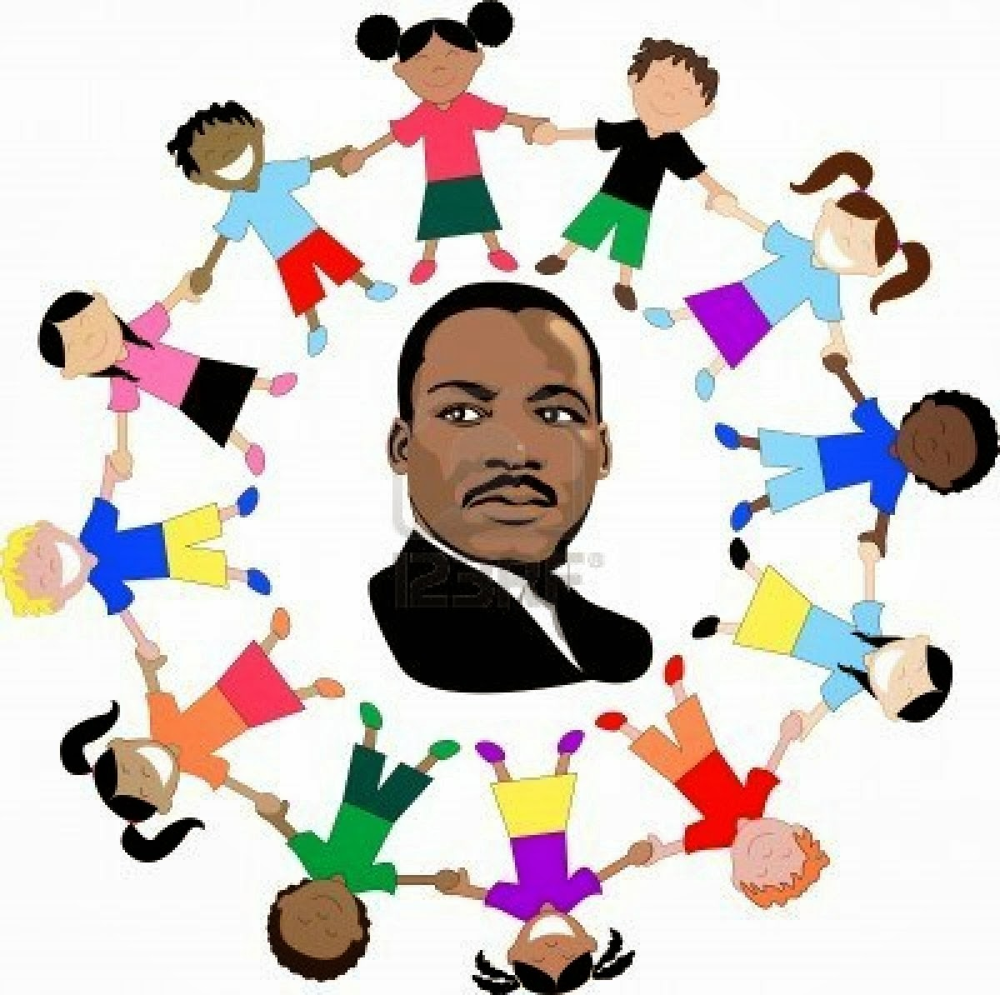  This Photo by Unknown Author is licensed under CC BY-NC-ND | MLK Holiday  No School
26 | 27 | 28 | 29 | 30 | 31
 | Catholic Schools Week  Begins  Book Fair |  |  |  | Sock Hop
 | CATHOLIC SCHOOLS: | lEARN | SERVE | LEAD | SUCCEED

