Nature/ Plant Project

Teacher: Ms. Favuzzi
Grades: 4th, 5th, 6th, 7th, and 8th
Due Date: May 13th, 2020
Link: https://www.youtube.com/watch?v=TZznOFyjq08&t=20s
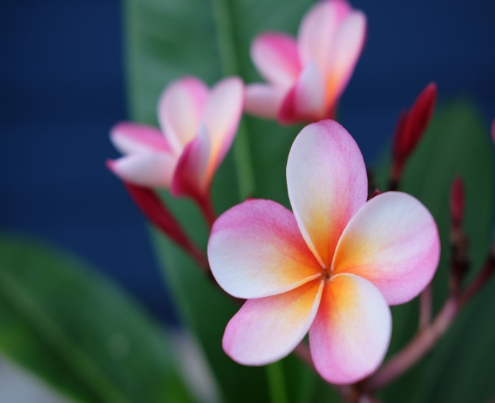
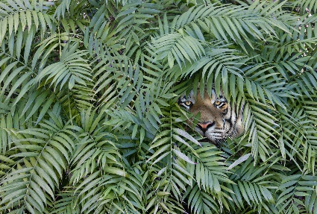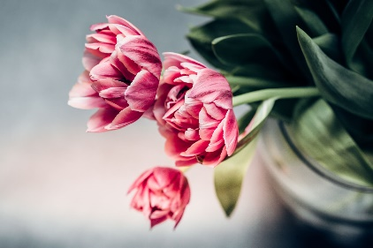
Materials:
- Students may use any materials that they have at home.
- If you do not have blank paper at home, you may use any type of notebook paper, cardboard, etc.
- Recommended materials:
  - Pencils
  - Pens
  - Paint
  - Markers
  - Colored pencils
  - Chalk
  - (These materials are NOT required).

Directions: (Please watch the YouTube video, linked above, for a demonstration on the project.)
- Students will either go outside and observe a plant, flower, grass, tree, etc. or observe a house plant that they have.
- Draw or paint a picture of the nature object that you chose by looking at it from life.
- Each Grade will have an individual part of the assignment to add.
- If you do not own a house plant or have any nature around your house/ apartment/ etc., you may look up a photo of a plant online to draw.
- Please submit these drawings to me by email @ sfavuzzi@hcscrusaders.com
- If you have any questions at all, please email me.

4th and 5th Grade
In this project, I would like you to demonstrate your knowledge of VALUE.
Watch this video on value and incorporate light, darkness, and contrast into your pictures: https://www.youtube.com/watch?v=AAwYHNo31ZQ

6th, 7th, and 8th Grade
In this project, I would like you to demonstrate your knowledge of FORM
Watch this video on form and incorporate form by using light and shadow effects to your images: https://www.youtube.com/watch?v=9DIPs3T2dQk
For more information on creating depth in your images, here are some more sources:
https://www.youtube.com/watch?v=8P6OPDgEqw4
https://www.youtube.com/watch?v=vMr6eimcolc
https://www.youtube.com/watch?v=NLK_r7tnKlQ
Rubric:
- Student did not draw an element of nature. They Handed in a project that did not have to do with the lesson.
- Student drew an element of nature but did not finish the project.
- Student drew an element of nature but did not demonstrate their element of art.
- Student drew an element of nature, plant, etc. and demonstrated the element of art for their grade. They turned in a finished project.

