Holy Cross School
240 NORTH BISHOP AVENUE
SPRINGFIELD, PA 19064
610-626-1709+610-626-1859 (fax)
November 25, 2020

Dear Parents, Grandparents and Guardians,

Today, heavenly Father, we pray for family unity. As we prepare to celebrate Thanksgiving, let us give thanks for our family members, whether we’ll be with them in person or in thought. We pray that families will soon be safely reunited in love. Amen.

I am attaching several flyers for your perusal. We are trying to do some nice things for the children this Christmas. It has been tough on them as well as the adults.

Remember, there is no school this Monday, November 30th. Classes resume on Dec. 1. Enjoy this extra day of rest.

Lately, we have been getting lunch deliveries for some students. This is not permissible. If no one is in the office, the delivery person cannot leave a lunch. Please either pack a lunch or order from McGillicuddy’s They do provide a nice lunch for the cost. Thank you.

Please have your children here on time. When children are late, it disrupts the morning routine. I appreciate your cooperation in this matter.

I am attaching the December calendar. Please remember that if you go out of state, you are supposed to quarantine for 14 days after you return home.

Have a safe and Happy Thanksgiving.

Sincerely,

Dr. Worrilow 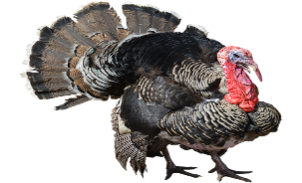
This Photo by Unknown Author is licensed under CC BY-NC

