Holy Cross School
240 NORTH BISHOP AVENUE
SPRINGFIELD, PA 19064
610-626-1709
610-626-1859 (fax)
December 3, 2020

Dear Parents, Grandparents and Guardians,

A few things that have come up this week:

- Tomorrow the children may dress down in Christmas clothing, etc.
- Those students who are virtual may come to school during the time that their class will be in the gym for their items. Teachers will let you know what time their class will be coming.
- The parish will be selling calendars again this year. I will be attaching 2 flyers with information on the sale. Students can win prizes and be entered into a drawing for a tuition credit and the student who sells the most calendars will receive a $100.00 gift card.

Please continue to access your child(ren)’s health. Please take their temperature in the morning and if they feel sick, please do not send them to school. Thank you.

Have a great weekend! God bless you.

Dr. Worrilow

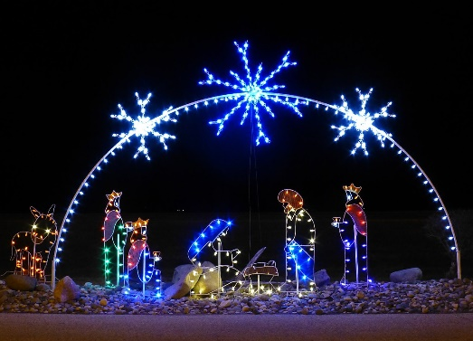
This Photo by Unknown Author is licensed under CC BY-SA

